YEAR 8 SCIENCE – ENERGY TEST REVISION

**ANSWER KEY**

**1** Define the term ENERGY; the ability to do work

**2** Classify the following types of energy as either Kinetic (K) or Potential (P) and give 2 examples of each.

|  |  |  |  |  |  |
| --- | --- | --- | --- | --- | --- |
|  | **K or P?** | **TWO EXAMPLES** |  | **K or P?** | **TWO EXAMPLES** |
| **Chemical** | **P** |  | **Elastic** | **P** |  |
| **Mechanical (motion)** | **K** |  | **Electrical** | **K** |  |
| **Sound** | **K** |  | **Gravitational** | **P** |  |
| **Radiant (light)** | **K** |  | **Thermal (heat)** | **K** |  |

**3** Identify which factors affect the total amount of:

1. Kinetic energy; velocity and mass
2. Potential energy; height and mass

**4 a)** Explain the difference between an energy transfer and an energy transformation.

TRANSFER = Energy is passed on from one object to another

TRANSFORMATION = The type of energy changes

**b)** Complete the following sentences using the words **transferred** and/or **transformed**.

On a table, when you slide a box across it, the chemical energy in your body is transformed to kinetic energy to move your hand. When you push the box, the kinetic energy in your hand is transferred to move the box.

**5** Define what is meant by *wasted* energy; energy that is not usefully transferred or transformed

**6** Identify the **units** needed for each of the following in the KE and GPE formulas:

1. mass  kg (kilograms)
2. velocity m/s2 (metres per second)
3. time s (seconds)
4. height m (metres)
5. gravitational acceleration m/s2
6. Kinetic energy J (joules)
7. Potential energy J

**7** Draw an energy chain to show what energy transfers/transformations occur during the following processes;

1. A violin makes a sound when you draw the bow across the string. (starting with a person moving the bow).

Chemical (stored in persons muscles) 🡪 kinetic (hand) 🡪 kinetic (violin strings) 🡪 sound +heat

1. A car driving along a road

Chemical (petrol) 🡪 kinetic + sound + heat

**8 a)**  State The *Law of Conservation of Energy*; energy cannot be created or destroyed, only transferred or transformed.

**b)** Answer ***True* or *False*** for each of the following statements about the Law of

Conservation of energy:

**T** The totals of all energy transfers and transformations when work is done

must equal the initial energy put into the system.

**T** Energy not used to do work can be given off as waste energy.

**F** The energy stored in a stretched spring is equal to the energy

required to stretch that spring plus the energy lost as heat to friction.

**9** Consider the points A, B, C and D on the missile launch diagram below:

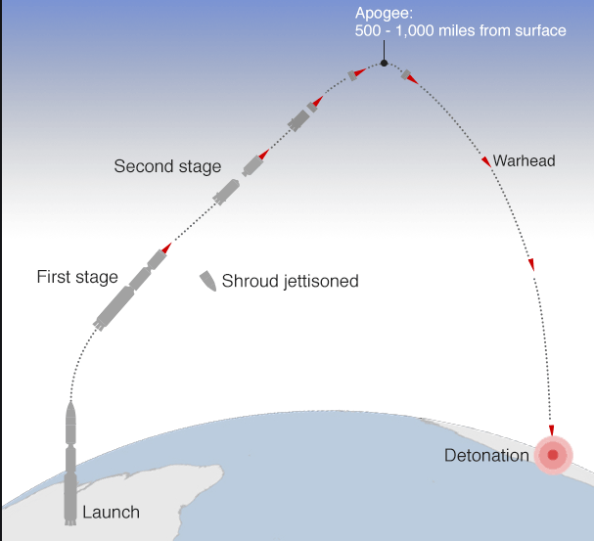

B

C

A

D

1. At which point (A, B, C or D) does the missile have the **least** gravitational potential energy? Explain. A
2. At which point (A, B, C or D) does the missile have the **greatest** amount of kinetic energy?

Explain. A

1. At which point (A, B, C or D) does the missile have the **greatest** gravitational potential energy? Explain. C

**10** Completethe table below to identify the energy transformation caused by each energy converter:

|  |  |  |
| --- | --- | --- |
| Main energy form **used** | Energy converter | Main energy form **produced** |
| ELECTRICAL | light bulb | LIGHT |
| ELECTRICAL | speaker | SOUND |
| CHEMICAL | car | KINETIC |
| CHEMICAL | bicycle | KINETIC |
| LIGHT | plant | CHEMICAL |

**11** Compare the waste energy of television A with television B shown below and explain which television would be considered the best to use.

 

Sound: 1800J

Light: 1800J

Heat: 400J

**Television B**

4000J

Light: 1500J

Heat: 1000J

Sound: 1500J

**Television A**

4000J

TV B – More of the electrical energy is transformed into useful light & sound (least wasted as heat)

**12** Classify the following as a type of potential energy or kinetic energy (use the letters KE or PE)

**a**. A bicyclist pedaling up a hill KE **f.** An archer with his bow drawn PE

**b**. A volleyball player spiking a ball KE **g**. A baseball thrown to second base KE

**c.** The chemical bonds in sugar PE **h**. The wind blowing through your hair KE

**d**. Walking down the street KE  **i.** Sitting in the top of a tree PE

**e**. A bowling ball rolling down the alley KE j. A bowling ball sitting on the rack PE

**13** The diagram below shows a basketball after it has been thrown by a player:

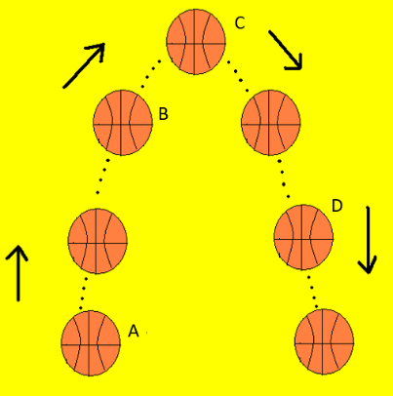

Choose the graph below that best represents the potential and kinetic energy of the ball at each labelled position (A,B,C and D). Explainyour choices.

|  |  |  |  |  |
| --- | --- | --- | --- | --- |
| **Graph 1** | **Graph 2** | **Graph 3** | **Graph 4** | **Graph 5** |
|  |  |  |  |  |

A = graph 3 B = graph 4 C = graph 5 D = graph 2

**14** Calculate the kinetic energy of a 2.56 kg ball travelling at 16 m/s

EK = 0.5mv2

EK = 0.5 x 2.56 x 162

= 327.68J

**15** Fearless Felix is on his balloon 30,000m in the air above the ground. With all his equipment his mass is 145kg. Calculate his gravitational potential energy before he jumps.

EP = mgh

= 145 x 9.8 x 30000

= 42,630,000J

**16** A rollercoaster is at the top of its climb at 82 metres and weighs 900kg. Calculate the GPE of the roller coaster.

EP = mgh

= 900 x 9.8 x 82

= 723240J

**17** Calculate the KE of a bike rider who has a mass of 55kg and riding 3m/s.

EK = 0.5mv2

= 0.5 x 5 x 32

= 22.5J

**18** For each of the following, **identify which type of energy** is being described, **then calculate it.**

1. You serve a volleyball with a mass of 2.1 kg. The ball leaves your hand with a speed of 30 m/s. KINETIC ENERGY 0.5 x 2.1 x 302 = 945J
2. A baby carriage is sitting at the top of a hill that is 21 m high. The carriage with the baby weighs 12kg. GRAVITATIONAL POTENTIAL 12 x 9.8 x 21 = 2469.1J
3. A car is traveling with a velocity of 40 m/s and has a mass of 1120 kg.

KINETIC 0.5 x 1120 x 402 = 896000J

1. A block is sitting on a platform 20 m high. It weighs 79 kg.

GRAVITATIONAL POTENTIAL 79 x 9.8 x 20 = 15484J

1. A roller coaster is stopped at a 72 m high point and weighs 966 kg.

EP  = 966 x 9.8 x 72

= 681609.6J

**19** Calculate the kinetic energy of a 3-kilogram ball that is rolling at 2 metres per second.

EK = 0.5 x 3 x 22

= 6J  
  
**20** Two objects were lifted by a machine. Object X had a mass of 10 kilograms, and was lifted at a speed of 4 m/sec. Object Y had a mass of 20 kilograms and was lifted at a rate of 8 m/sec.

**a.** Which object had more kinetic energy while it was being lifted? OBJECT Y (more mass and more velocity)

**b**. Which object had more potential energy when it was lifted to a distance of 10 metres?

Show your calculation. OBJECT Y (greater mass)

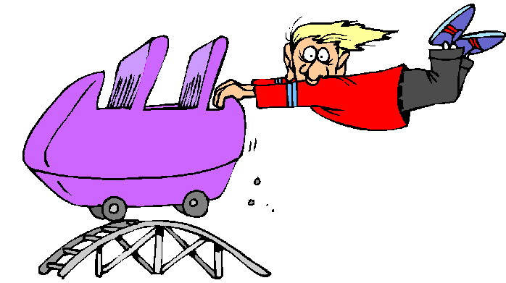

**INVESTIGATION**

A pair of students wanted to test which ball material created the loudest sound when they drop it. They conducted an experiment where they dropped the same sized ball from 2m and each ball was made of a different type of material. They recorded the level of sound made by each ball. The results are in the table below.

|  |  |  |  |
| --- | --- | --- | --- |
|  | **Loudness of ball bounce (dB – decibels)** | | |
| **BALL MATERIAL** | TRIAL 1 | TRIAL 2 | AVERAGE |
| Rubber | 110 | 150 | 130 |
| Silicon | 55 | 62 | 58.5 |
| Leather | 80 | 91 | 85.5 |
| Steel | 200 | 220 | 210 |

1) Complete the table above by calculating the average sound level of each material.

2) a) State the independent variable for this investigation. Ball material

b) State the dependent variable for this investigation. Loudness of ball bounce (measured in dB)

c) Suggest TWO control variables.

Eg; size of ball, mass of ball, surface ball dropped on, height ball dropped, force ball released when dropped, tool used to measure loudness.

3) Suggest one source of error for this investigation.

Eg; tool used to measure loudness not calibrated or not detecting sound clearly, different force used to drop ball, height differences in the drop, recording dB recording inaccurately.

4) Suggest one way they could improve the reliability of this experiment.

More trials, repeat experiment, test more materials, larger sample size

5) Suggest one way they could improve the validity of this experiment.

Calibrate/make sure tool used to measure loudness is functioning and recording accurately, repeat sound measurements, control more variables such as…

6) Graph the average results below.

7) Write a conclusion for this experiment.

The steel ball was the loudest bounce and silicon was the quietest bounce. Refer to results to provide evidence.

GOOD LUCK FOR YOUR TEST!!!!